**Homework View**

1.Create a view that show all category information from table category. You view should store data in the

form as this figure:

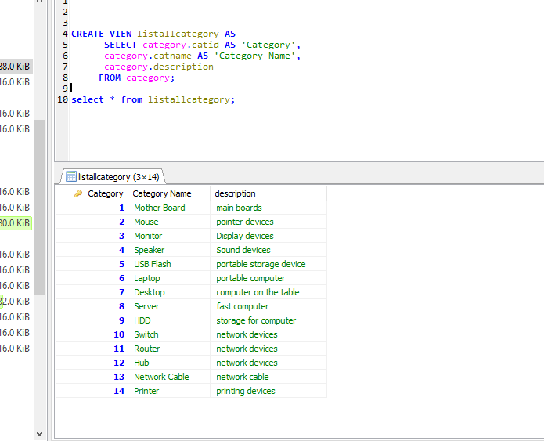

2. Create a view that represents a report of products that include this information: product id, product name,

quantity, unit price, subtotal, category name and store name. Your report should list all products even

they don’t have category or store.

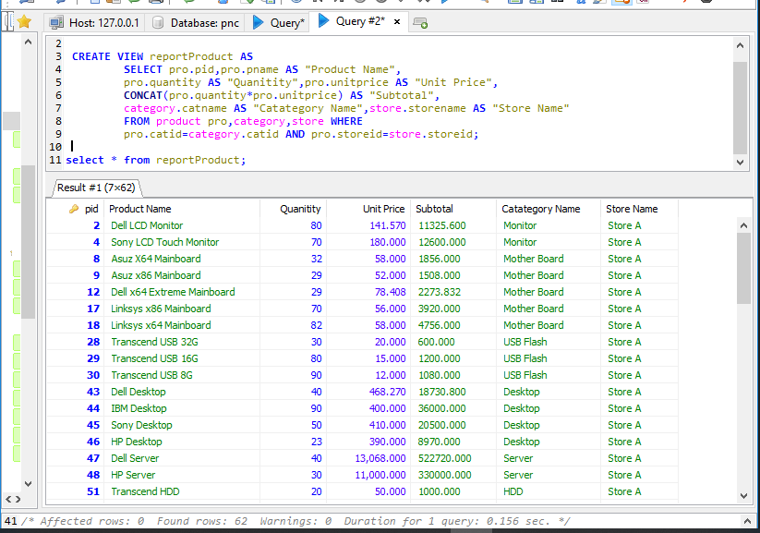

3. Create a view that represents a report of store manager by including this information: manger id,

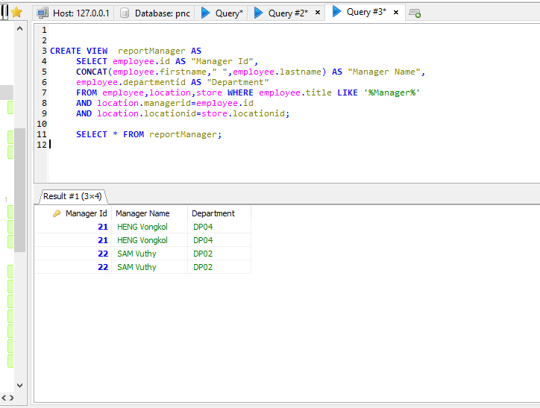manager name, manager department, location and store name.

4.Create a view that represents a report of the product summarization by including this information:

category name, number of product in each category, total quantity of product, total amount, minimum

quantity, maximum quantity, average quantity and total cost of product group by category.

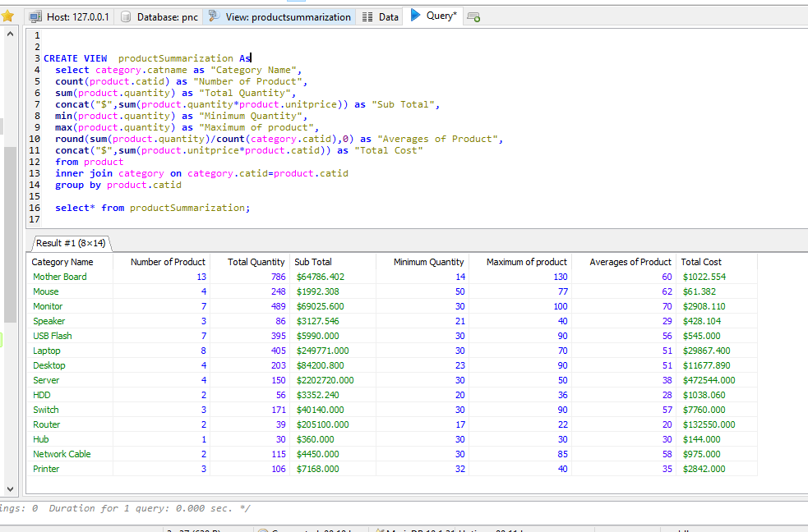

5. Create a view that represents a report of sales in 2009. This report should include this information: sale

id, product name, quantity sold, unit price, subtotal and seller name.

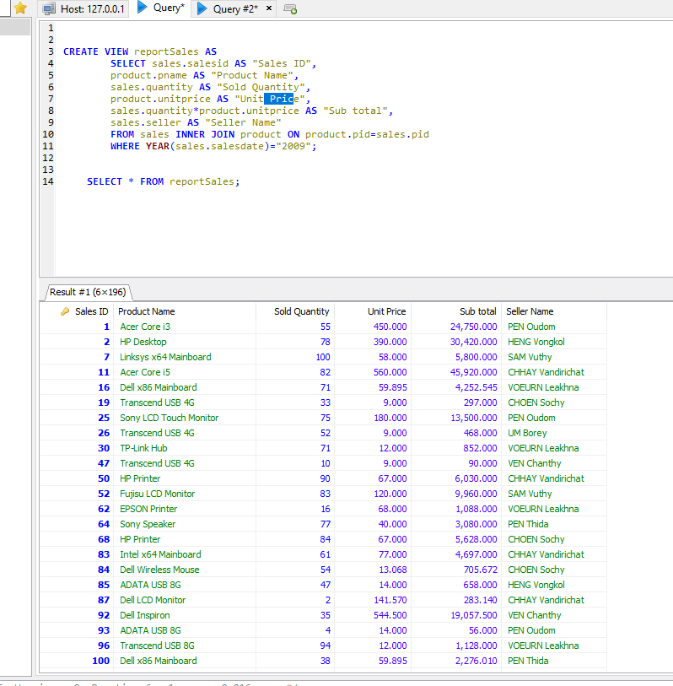

6. Create a view that represents a report of seller from 2009 to 2010 by including this information: seller

name, minimum quantity sold, maximum quantity sold, total quantity sold and total amount.

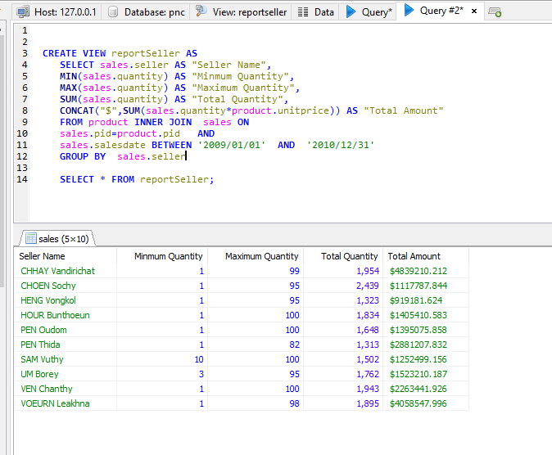

7. Create a view that represents a sale report by year. Your report should include this information: year,

minimum sale, maximum sale, average sale and total sale.

